
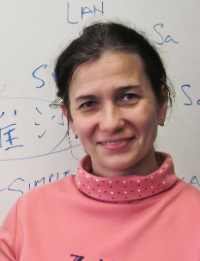



“…Rivers of living water.” (john 7:38)

larisa golovko, phd
&

Vadim chernov, ms

support team:

David Johnson, MS (Zion Geophysics), Randy McSweeney, Dr. Russell Stands-Over-Bull, Thomas Fate, BS (AccuCore Technologies, LLC), Michael Kelly, B.Sc, P.Ag (Bio-Kinetic Systems, Inc), Jeffrey Law (Autogrow Inc), Sergei Zhmako, MS, MBA (IBA Group NA), Jeff Ferguson, MBA (Ferguson & Associates), Anand Mohandas MSc. Space Science &Tech (BRIDGE), Sourav Karmakar (InfinosTech)

We propose The Laser Beam Method for Anisotropic Frequency Sounding of Induced Polarization for the Detection and Control of high pressure zones of water sources to support autonomic colonies on Mars, other planets and cosmic bodies ("The LBM AFSIP-DC method").
  - Detecting and mining deep sources of water and energy on mars

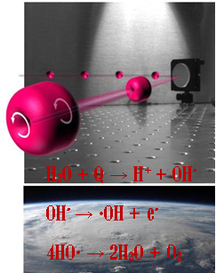
  - Detecting and mining deep sources of water and energy on mars

STATE of affairs
Mars geological history is like that of Earth. However, volcanic activity stopped and Mars has proven to have solid core of magma – weak magnetic shield from radiation. High winds, low oxygen and excess CO2 comprises very hostile environment on the Mars surface. Sufficient molecular water source is critical for establishing a colony on Mars.
Water was discovered frozen on the surface and in soil as permafrost and salty brines (NASA 2012). Rovers has been traversing Mars surface and gave us information about near surface soil properties. But how can we gain more information about deeper geology? Geophysics! Many geophysical techniques have been successfully used on Earth for more than a century to study underground geology and prospect for hydrocarbons (oil & gas), water and minerals. Methods induce various physical fields into the ground and measure response. They can be classified by the force they use into seismic, gravitational, electromagnetic, DC electrical [1]. Advantage of such methods over satellite imagery are their ability to “see” into the ground, from just couple of inches [2] to thousands of feet [1] deep. A simple four-electrode probe has been measuring Moon soil electrical resistivity and new electromagnetic methods proposed[3, ] .[4]
Fig.1. Laser beam polarization and chemical reaction for extraction of oxygen, positrons and electrons in the atmosphere from water extracted from the bowels of the planet.[3]
However, most of the methods require extensive on-ground setup of heavy elaborate equipment and energy source to conduct such deep investigations.
- Can there be vast subsurface reservoirs of highly pressurized water and/or hydrocarbons at 1-6 km depth beneath Mars surface?
- Can we detect such reservoirs reliably from satellites orbiting Mars and minimal on-ground set-up or without such setups in principle?
Here we propose a novel technique of The LBM AFSIP-DC method to address this challenge.
Unlike higher frequency EM methods, which do not penetrate deeper than 30 feet, the depth of The LBM AFSIP-DC method is comparable with seismic. However, in contrast with traditional seismic, this modified HRES-IP method relies on orbiting satellites to transmit and receive low-frequency signal from magnetic loops in the high frequency and high energy transmitted laser beam that falls on the surface giving it distinct advantage over all other geophysical methods for searching of water on Mars. And we accept the low-frequency response on another high-frequency beam on any frequency, which with a high speed draws a grid of profiles with a given geographical accuracy. Of course, the accuracy and timing of such work depends on the quality of the equipment and the power of the transmitters. We have assembled an initial team of experts to make this proposal a reality, and need NASA help in this endeavor.
We can find water on Mars and build a community there faster and with less risk!
- Can we try it on Earth first? Can it be Arctic sea under ice? Or water in Sahara?

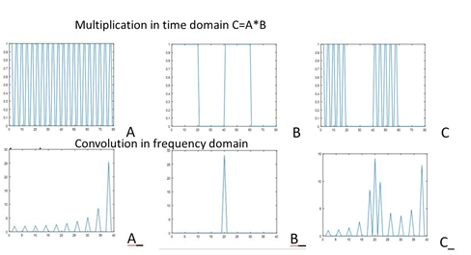
Proof of concept
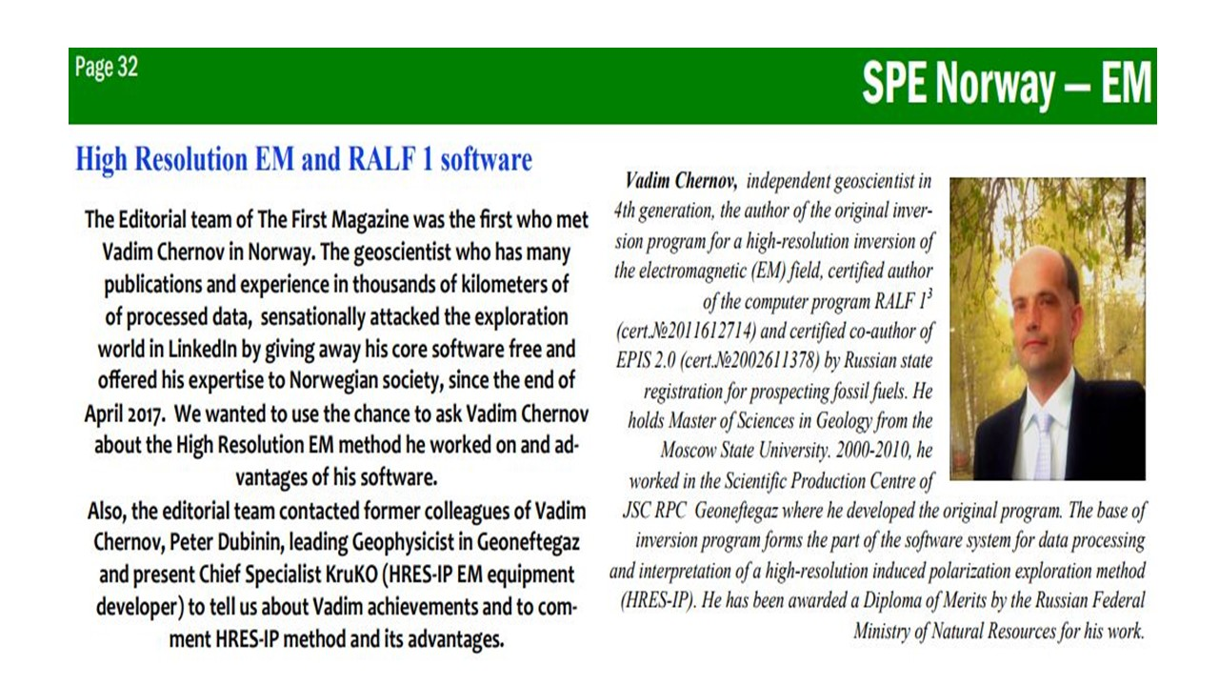
We have a question for the specialists who deal with remote sensing. What will happen with the signal on the surface of a planet when high frequency signal which was received by satellite and modulated by a low-frequency rectangle signal as power on/power off? What is the depth of penetration of such signal into planet with low-frequency rectangle, f.e. 0.2 Hz (carrier frequency less than 1 kHz, for example a periodic pulsed laser system)? The figure above shows a schematic modular signal and its spectrum in frequency. The source of the signal (60kW) can be an orbital geostationary satellite at the distance of 10,000 km from the surface of the planet or a slow-moving satellite or stratospheric sphere with an angular velocity of 10 degrees for 1 hour on less distance from the study points. The receiver can be horizontal magnetometer on the surface and two electrodes with a distance between them of 100 m, located along the radius at the distance of 3-20 km from the point of incidence of the beam. Frequency range for receiver is 0.03-30 Hz. Components B_{r} and E_{r}. Or we can use high-frequency detection on second satellite for component B_{z} for better performance. For the frequency range 0.03-30 Hz, there is a software package with a specific inversion algorithm and its results for the electromagnetic field component E_{x}. The depth of such electromagnetic survey is 6 km with a depth step of 100-200 m. The accuracy of calculating the saturation of hydrocarbons or water is 2 m. [5]–[7]
Fig.3. Author of the idea of LBM AFSIP-DC, Vadim Chernov [5]
Fig.2. Schematic time domain and frequency domain characteristics of the EM signal generated in the LBM AFSP-DC method and carried by laser beam
Head of the Department of Geophysics of the Main Directorate of Geological Exploration Works OJSC "LUKOIL" Kobzarev Grigory Y. in May 2009 said: “An attempt to search for the authors of a tool for predicting oil-saturated thicknesses can only be welcomed. To facilitate the perception of the comparison, we have identified a zone with total thicknesses of more than 2.1 meters on the forecast oil-saturated thickness map. In general, the authors obtained an interesting result, but it differs from the results obtained with the approach for identifying oil-promising zones by the Phase Parameter anomalies”.

HISTORY and SUCCESS
Fig.4. The area of measured data of HRES-IP method in Poland. Curves of amplitude and phase of measured signals in frequency domain range 0.1 - 30 Hz.
Method had 70-90% success rate in Russia, China and around the world for detecting deep deposits of mineral water and hydrocarbons, from V. Chernov’s reports to Russian Geological Survey, 1000 km of EM surveys per year for more than 10 years. [5], [6]
The maximum of blue colors is high mineralized water, red colors are gases. There are two main parameters in cross sections by EM inversion. 1/ ` polarization is polarizability (chargeability) or polarization for many layers. Mineral water shows high level of this parameter and hydrocarbons don't have it.
2/ Anisotropy of resistivity. High parameter means vertical resistivity is bigger than horizontal. It is when high resistivity layer of small thickness is in cross section. Hydrocarbons and gases have very high resistivity and small thickness. This means high level of anisotropy of resistivity. Red color of polarizability in left part of picture means low polarizabilities. Blue color of anisotropy in right part of picture is means low anisotropies.
Fig.5. Geoelectric sections, obtained by 3 profiles with RALF-1 software, on a gas field in Poland.
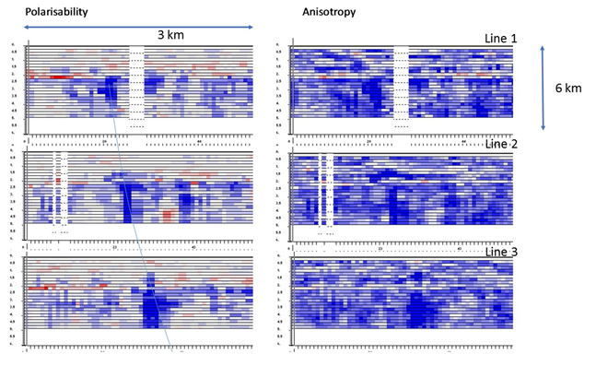
And both blue colors mean minimal prospectively parts of cross sections for gases and hydrocarbons but not for water. Red means high prospective parts for hydrocarbons, but dark blue means high prospective parts for water. And we see the big blue zone which is in left part of all of 6 cross sections.
It is geological faults zone. And this zone is changing from upper cross sections to bottom cross sections.
It is well known faults zone to which the gas field is connected. Those conclusions were made only by electromagnetic research without involving any a priori information. We can see it.

Analogies for laser system method
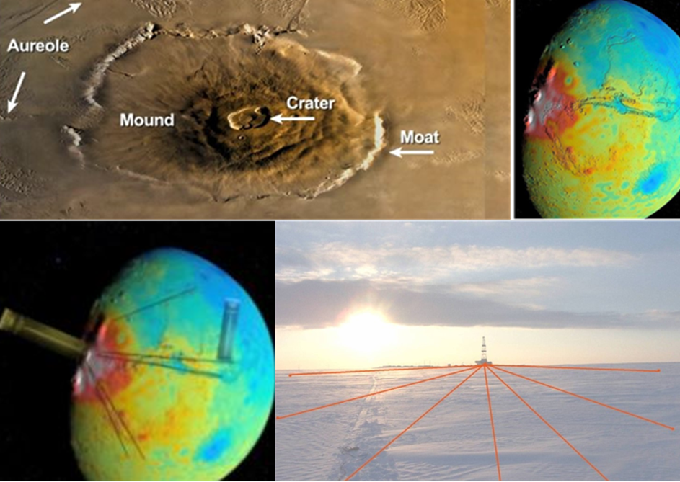
1/ Sounding with vertical currents is a method of electrical exploration related to exploration geophysics. Sounding with vertical currents is used in the search for oil and ore deposits. The electrical prospecting method for probing with vertical currents was proposed in the 1980s by Vladimir Mogilatov. The method uses the possibilities of a circular electric dipole, as the source of the electromagnetic field. When conducting a circular electric dipole is formed from 8 grounded electrical lines. Such a source creates in a toroidal system of secondary currents underground.
2/ The early used on Earth technology is based on high-precision measurements on the day surface of an alternating electromagnetic field of an earthed source - an electric dipole placed in a cased well. By changing the position of the electric dipole in the well (above and below the reservoir) and analyzing the distribution of currents on the surface of the Earth, it is possible to estimate the change in the electrical properties of the target horizon. In addition to the traditional difference of productive layers in electrical prospecting due to their specific electrical conductivity, the modern methodology uses information on the frequency dispersion of electrical conductivity, i.e. on the induced polarization of the medium. The use of the technology makes it possible to assess the position of the contour of the deposit, discovered by at least one well, and, in some cases, to divide the outlines of the "multi-story" deposit, and thereby significantly reduce the volume of exploration drilling.
Fig.6. Examples of EM soundings using methods, which are similar to The LBM AFSIP-DC method, performed on Earth and on Mars at different times by different civilizations.

Abundance of hydro-thermal deposits on Earth
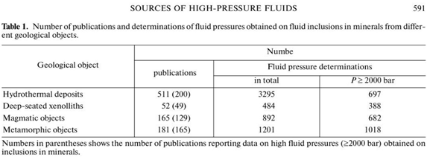

From [8]. Could Mars also have plenty of deposits underground just waiting to be discovered?

Creating livable conditions on Mars
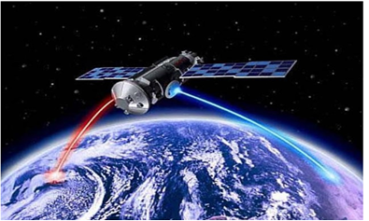
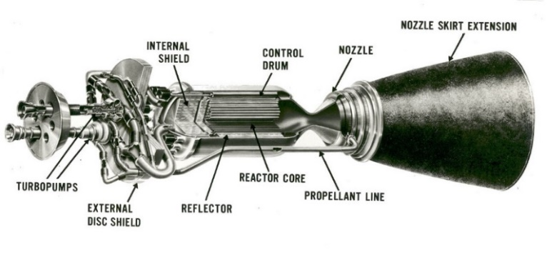
Moreover, if rockets and stratospheric spheres are used on hydrogen, then as the production of hydrogen from water increases, the coverage area of the investigated territory can be increased by increasing the number of devices involved for this purpose. And we can create the good atmosphere and climate for our life. And if we find hydrocarbons at some depth, then we can create a natural feeding medium for living organisms in natural conditions. Water under high pressure and temperature is a source of water for living organisms, a source of energy for terrestrial life, a source of oxygen in the atmosphere for colonies of settlers, fuel for movement and autonomous generators.
Fig.7. A satellite in orbit around the planet that emits and receives laser beams during the LBM AFSIP-DC method.
Fig.8. The devices proposed for use during operation of the LBM AFSIP-DC method.
This is a reality for us to find a little of water in the Martian rocks, create new life and understand who we are and what we can do anywhere including our Homeland on Earth? Let's try?

references
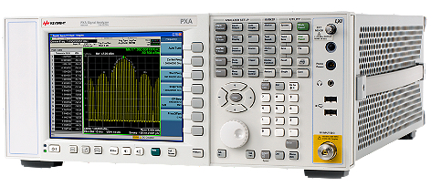
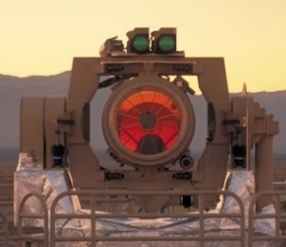
[1 ] Solid Earth Geophysics Encyclopedia (2nd Edition), Electrical & Electromagnetic, Gupta, Harsh (ed), 2nd ed., Berlin: Springer, 2011, pp. 604.
[2] L. Golovko, A. Pozdnyakov, and A. Pozdnyakova, “LandMapper ERM-02: Handheld Meter for Near-Surface Electrical Geophysical Surveys,” FastTIMES EEGS, vol. 15, no. 4–Agriculture: A Budding Field in Geophysics, pp. 85–93, Dec. 2010.
[3] N. Jhajj, I. Larkin, E. W. Rosenthal, S. Zahedpour, J. K. Wahlstrand, and H. M. Milchberg, “Spatiotemporal Optical Vortices,” Phys Rev X, vol. 6, no. 3, p. 031037, Sep. 2016.
[4] C. P. Sonett, “Electromagnetic induction in the Moon,” Rev. Geophys., vol. 20, no. 3, p. 411, 1982.
[5] V. Kalashnikova, “Why EM is not like Seismic? about EM for HC in simple words, and also about High Resolution EM technique,” “ First” SPE Norway, vol. 2, pp. 16–21, Jun. 2017.
[6] V. V. Chernov, “Modern search of oil fields and gas a method of high resolution electroinvestigation in Russia,” 2010.
[7] А. Gorunov, Е. Кiselev, I. Kondratiev, А. Safonov, K. Tertyshnikov, and V. Chernov, “The role of high-resolution electrical survey (HRES-IP) in complex of geophysical methods during exploration, prospecting and exploitation of oil and gas deposits.,” presented at the Geophysics of the 21st Century - The Leap into the Future, 2003, vol. Integration of the methods.
[8] V. B. Naumov, V. A. Dorofeeva, O. F. Mironova, and V. Y. Prokof’ev, “Sources of high-pressure fluids involved in the formation of hydrothermal deposits,” Geochem. Int., vol. 53, no. 7, pp. 590–606, Jul. 2015.

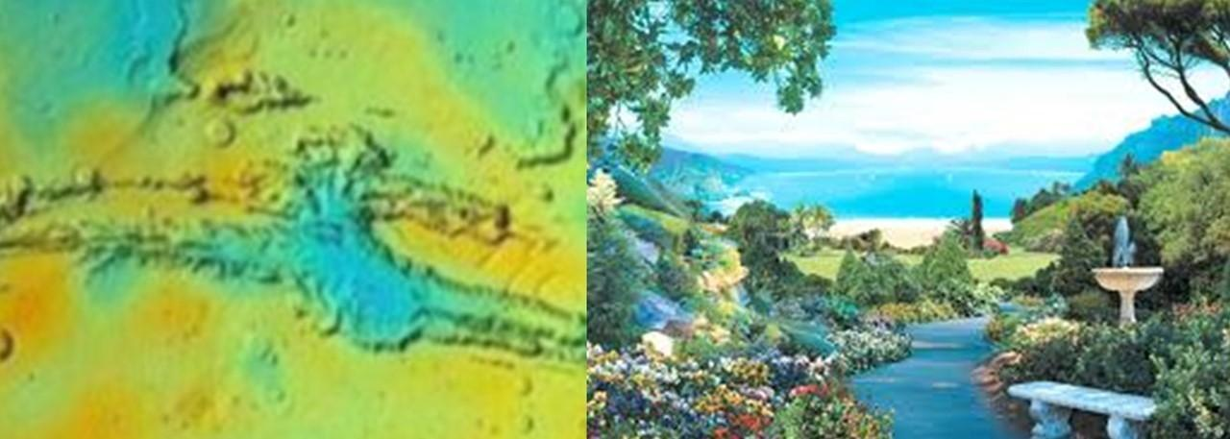

The essence of our proposal is water and an atmosphere for life on Mars in natural conditions.

